**1**

**CODE:**

<!DOCTYPE HTML>

<html>

<body>

<p style="color:orange; font-size:190%; text-align: center">1</p>

<p style="color:blue; font-size:190%; text-align: center">2</p>

<p style="color:red; font-size:190%; text-align: center">3</p>

<p style="color:green; font-size:190%; text-align: center">4</p>

<p style="color:darksalmon; font-size:190%; text-align: center">5</p>

<p style="color:cyan; font-size:190%; text-align: center">6</p>

<p style="color:deeppink; font-size:190%; text-align: center">7</p>

<p style="color:greenyellow; font-size:190%; text-align: center">8</p>

<p style="color:palegoldenrod; font-size:190%; text-align: center">9</p>

<p style="color:teal; font-size:190%; text-align: center">10</p>

</body>

</html>

**OUTPUT:**

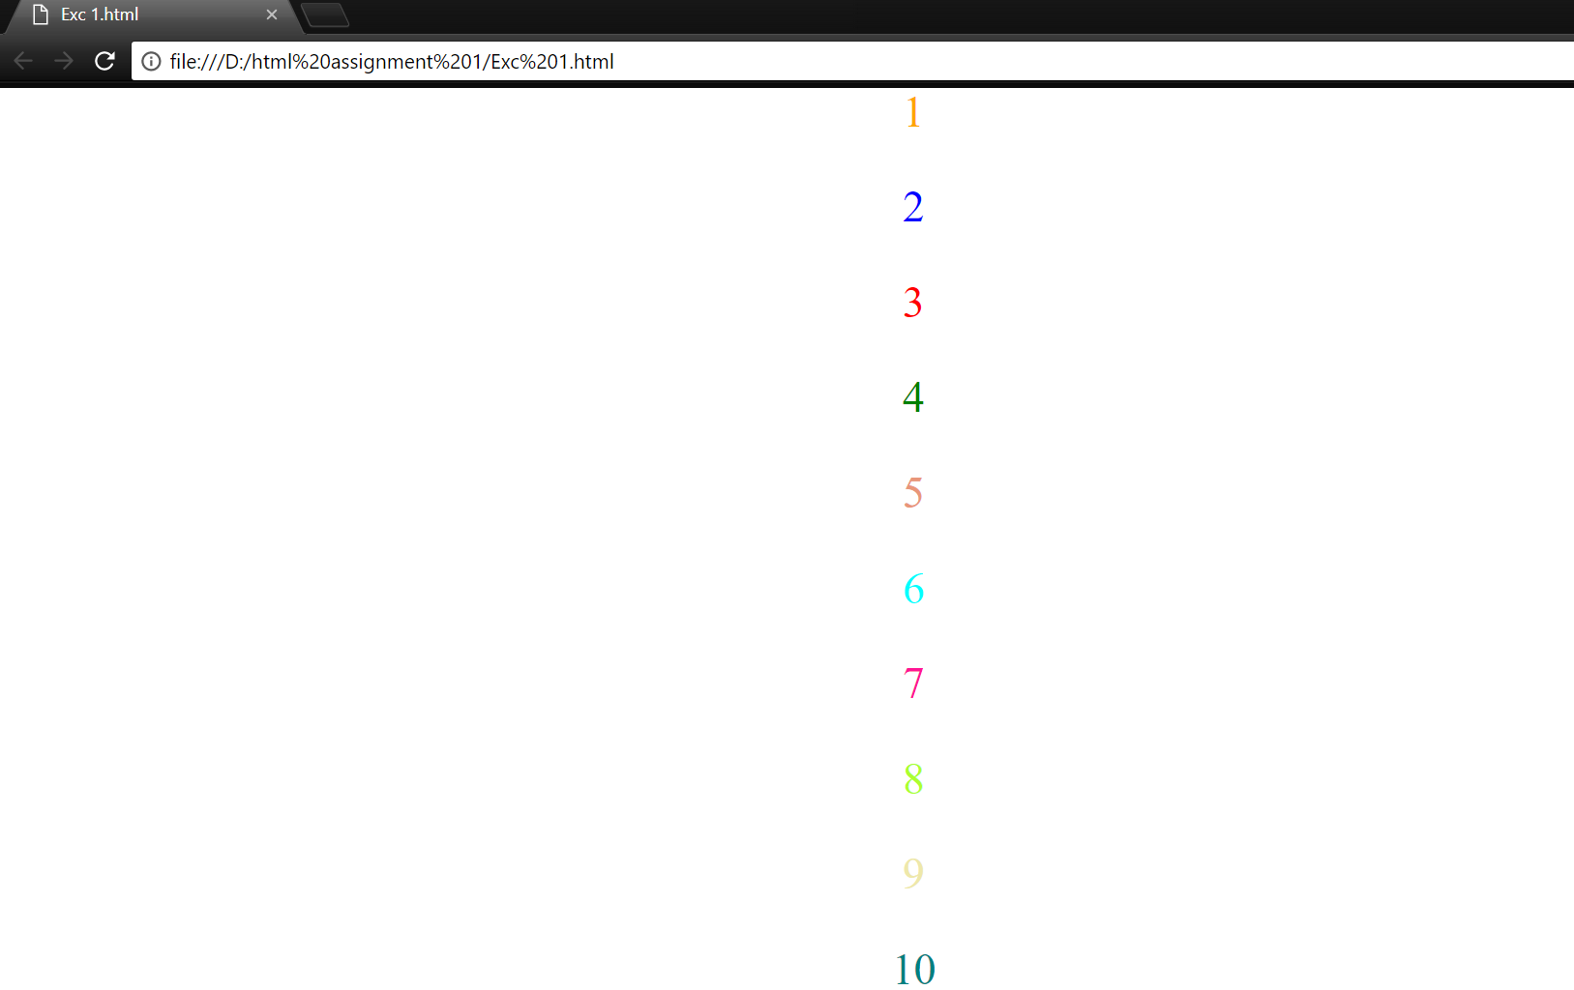

**2**

**CODE:**

<!DOCTYPE HTML>

<html>

<body>

<h1> <b> Unalphabetized List of Names </b> </h1>

<p> Basseda<sub>3</sub><br>

Mahmood<sub>7</sub><br>

Lee<sub>6</sub><br>

Hamada<sub>5</sub><br>

Dichter<sub>4</sub><br>

Almagren<sub>1</sub><br>

Omar<sub>8</sub><br>

Taeib<sub>10</sub><br>

Qawaqne<sub>9</sub><br>

Alshugran<sub>2</sub></p>

<h1> <b> Alphabetized List of Names </b> </h1>

<p> Almagren<br>

Alshugran<br>

Basseda<br>

Dichter<br>

Hamada<br>

Lee<br>

Mahmood<br>

Omar<br>

Qawaqne<br>

Taeib</p>

</body>

</html>

**OUTPUT:**

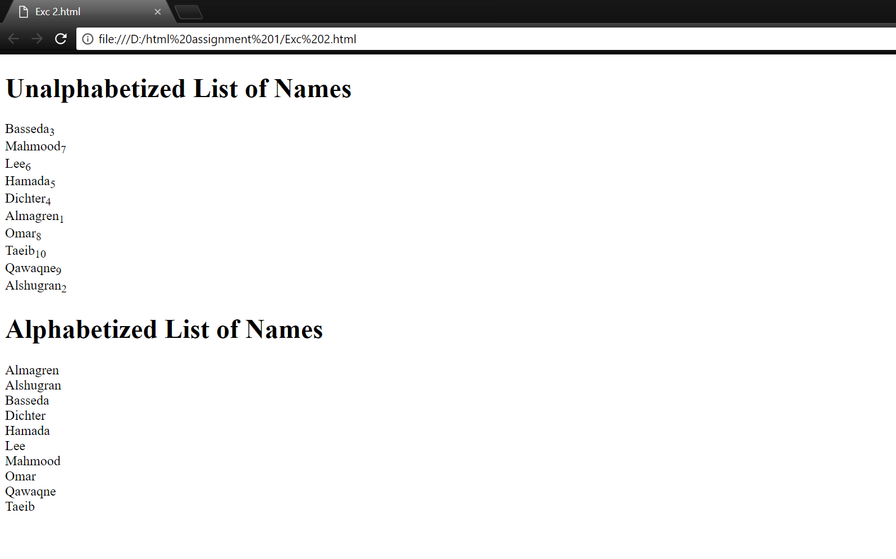

**3**

**CODE:**

<!DOCTYPE HTML>

<html>

<body>

<h3 id="t">This is the top of the page</h3>

<a href="#b">click to go to the bottom of the page</a>

<h2>Artificial Intelligence</h2>

<pre>

Artificial intelligence (AI, also machine intelligence, MI) is intelligence demonstrated by machines,

in contrast to the natural intelligence (NI) displayed by humans and other animals.

In computer science AI research is defined as the study of "intelligent agents":

any device that perceives its environment and takes actions that maximize its chance

of successfully achieving its goals.[1] Colloquially, the term "artificial intelligence"

is applied when a machine mimics "cognitive" functions that humans associate with other human minds,

such as "learning" and "problem solving"

</pre>

<pre>

The scope of AI is disputed:

as machines become increasingly capable, tasks considered as requiring "intelligence"

are often removed from the definition, a phenomenon known as the AI effect, leading

to the quip "AI is whatever hasn't been done yet.

"For instance, optical character recognition is frequently excluded from "artificial intelligence",

having become a routine technology.

Capabilities generally classified as AI as of 2017 include successfully understanding human speech,

competing at a high level in strategic game systems (such as chess and Go[6]),

autonomous cars, intelligent routing in content delivery networks, military simulations,

and interpreting complex data, including images and videos.

</pre>

<h2>Machine Learning</h2>

<p>

Machine learning is a field of computer science that gives computers the ability to learn without being explicitly programmed.

</p>

<pre>

The name Machine learning was coined in 1959 by Arthur Samuel.

Evolved from the study of pattern recognition and computational

learning theory in artificial intelligence, machine learning

explores the study and construction of algorithms that can learn

from and make predictions on data[3] – such algorithms overcome

following strictly static program instructions by making

data-driven predictions or decisions,through building a model

from sample inputs. Machine learning is employed in a range of

computing tasks where designing and programming explicit algorithms

with good performance is difficult or infeasible; example applications

include email filtering, detection of network intruders or malicious

insiders working towards a data breach, optical character recognition (OCR),

learning to rank, and computer vision.

</pre>

<h3 id="b">This is the bottom of the page</h3>

<a href="#t">click to go to top of page</a>

</body>

</html>

**OUTPUT:**

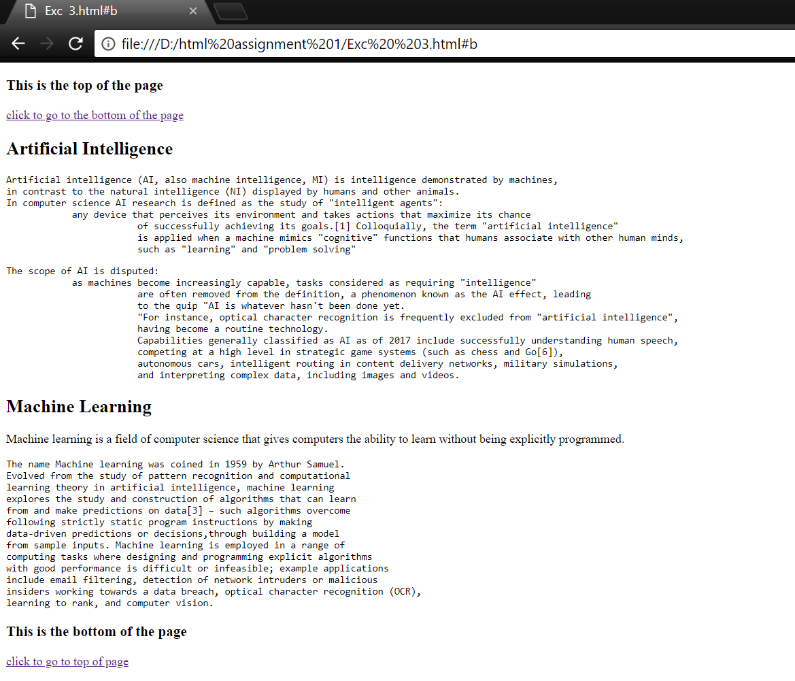

**4**

**CODE:**

<html>

<body>

<a href="https://www.google.com" target="_blank">

<img src="http://www.google.com/logos/2009/us_doodle4google09.gif" alt="Google search engine">

</a>

</body>

</html>

**OUTPUT:**

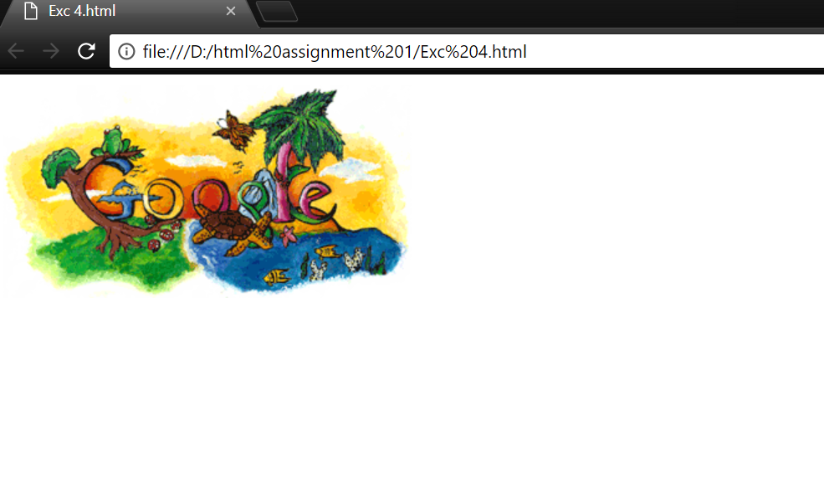

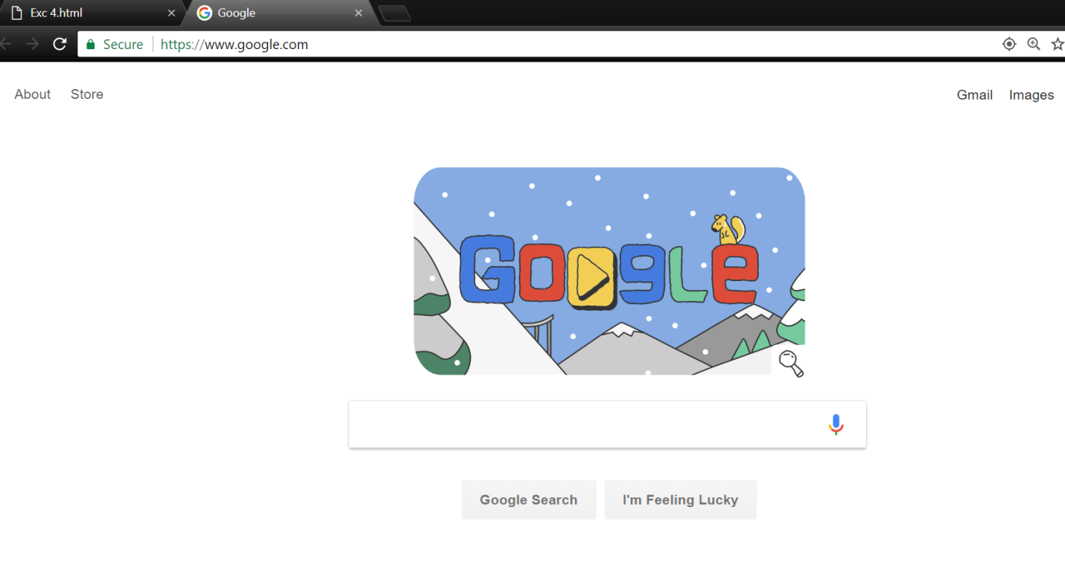**5**

**CODE:**

<!DOCTYPE HTML>

<html>

<body>

<label>NAME: </label>

<p style="color:red;">

<input type="text">

Please enter your name

</p>

<label>ADDRESS: </label>

<p style="color:red;">

<input type="text">

Please enter your address

</p>

<button type="button" style="margin:25px;">Submit</button>

</body>

</html>

**OUTPUT:**

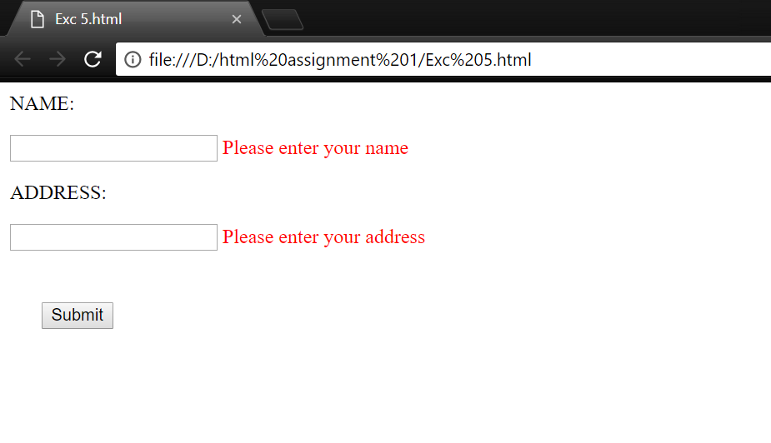**6**

**CODE:**

<!DOCTYPE HTML>

<html>

<body>

<table>

<tr>

<td>FirstName</td>

<!DOCTYPE html>

<html>

<body>

<table>

<tr>

<td>FirstName</td>

<td><input type="text"></td>

</tr>

<tr>

<td>LastName</td>

<td><input type="text"></td>

</tr>

<tr>

<td>Address</td>

<td><input type="text"></td>

</tr>

<tr>

<td>City</td>

<td><input type="text"></td>

</tr>

<tr>

<td>State</td>

<td><input type="text"></td>

</tr>

<tr>

<td>Zipcode</td>

<td><input type="text"></td>

</tr>

<tr>

<td></td>

<td><button type="submit" style="margin:10px;">Submit</button></td>

</tr>

</body>

</html>

**OUTPUT:**

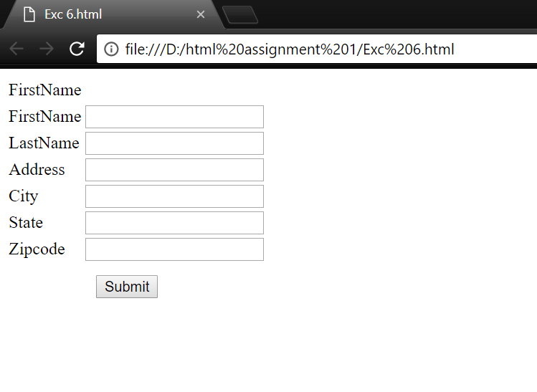**7**

**CODE:**

<!DOCTYPE html>

<html>

<head>

<style>

table,td{

border: 1px solid black;

border-collapse: collapse;

}

.ht{

height:50px;

}

.w1{

width:50px;

}

.w2{

width:500px;

}

.w3{

width:100px;

}

tr:nth-child(odd) {

background-color: #deefad;

</style>

</head>

<body>

<table style="width:100%">

<tr class="ht">

<td class="w1"></td>

<td class="w2"></td>

<td class="w3"></td>

</tr>

<tr class="ht">

<td class="w1"></td>

<td class="w2"></td>

<td class="w3"></td>

</tr>

<tr style="height:500px;">

<td class="w1"></td>

<td class="w2"></td>

<td class="w3"></td>

</tr>

<tr class="ht">

<td class="w1"></td>

<td class="w2"></td>

<td class="w3"></td>

</tr>

</table>

</body>

</html>

**OUTPUT:**



**8**

**CODE:**

<!DOCTYPE HTML>

<html>

<body>

<h1><b>WHAT IS AI?</b></h1>

<p>

From SIRI to self-driving cars, artificial intelligence (AI) is progressing rapidly.

While science fiction often portrays AI as robots with human-like characteristics,

AI can encompass anything from Google’s search algorithms to IBM’s Watson to autonomous weapons.

<br><br>

<img src="AI.jpg" alt="Artificial Intellugence" style="float:right;margin:10px;">

Artificial intelligence today is properly known as narrow AI (or weak AI), in that it is designed to perform a narrow task

(e.g. only facial recognition or only internet searches or only driving a car). However,

the long-term goal of many researchers is to create general AI (AGI or strong AI).

While narrow AI may outperform humans at whatever its specific task is,

like playing chess or solving equations, AGI would outperform humans at nearly every cognitive task.

</p>

<h1><b>WHY RESEARCH AI SAFETY?</b></h1>

<p>In the near term, the goal of keeping AI’s impact on society beneficial motivates research in many areas, from economics and law to technical topics such as verification, validity, security and control. Whereas it may be little more than a minor nuisance if your laptop crashes or gets hacked, it becomes all the more important that an AI system does what you want it to do if it controls your car, your airplane, your pacemaker, your automated trading system or your power grid. Another short-term challenge is preventing a devastating arms race in lethal autonomous weapons.

In the long term, an important question is what will happen if the quest for strong AI succeeds and an AI system becomes better than humans at all cognitive tasks. As pointed out by I.J. Good in 1965, designing smarter AI systems is itself a cognitive task. Such a system could potentially undergo recursive self-improvement, triggering an intelligence explosion leaving human intellect far behind. By inventing revolutionary new technologies, such a superintelligence might help us eradicate war, disease, and poverty, and so the creation of strong AI might be the biggest event in human history. Some experts have expressed concern, though, that it might also be the last, unless we learn to align the goals of the AI with ours before it becomes superintelligent.

There are some who question whether strong AI will ever be achieved, and others who insist that the creation of superintelligent AI is guaranteed to be beneficial. At FLI we recognize both of these possibilities, but also recognize the potential for an artificial intelligence system to intentionally or unintentionally cause great harm. We believe research today will help us better prepare for and prevent such potentially negative consequences in the future, thus enjoying the benefits of AI while avoiding pitfalls.

</p>

</body>

</html>

**OUTPUT:**

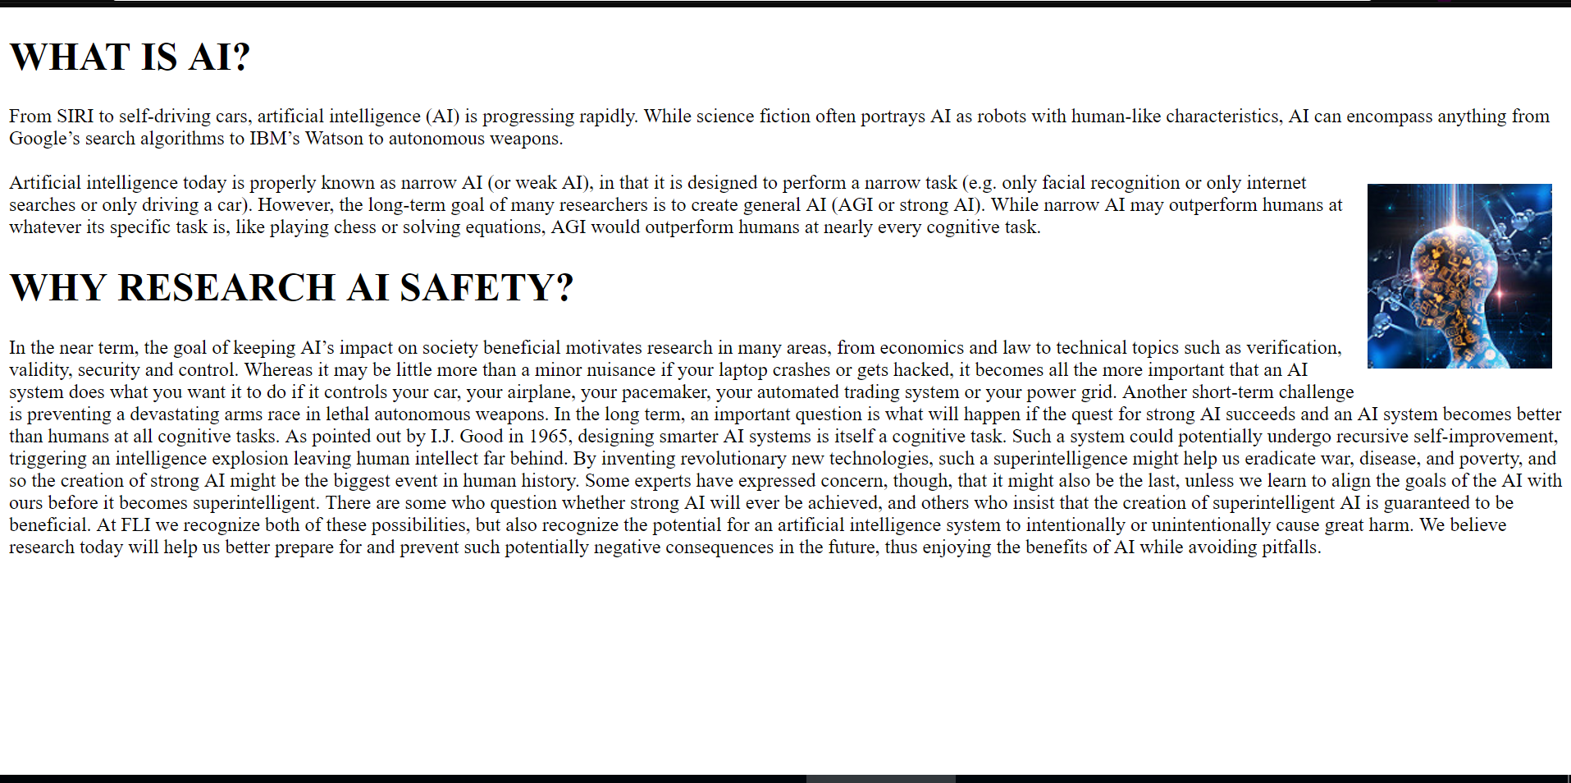

**10**

**CODE:**

<!DOCTYPE HTML>

<html>

<head>

<style>

body {

font-family: "Raleway",sans-serif;

font-size: 16px;

line-height: 28px;

width: 95%;

background: #fff;

}

</style>

<body>

<h1/>What is the Internet of Things?</h1>

<p>

The Internet of Things, or IoT, refers to billions of physical devices around the world that are now connected to the internet,

collecting and sharing data. Thanks to cheap processors and wireless networks, it's possible to turn anything,

from <span style="color:blue;">a pill</span> to an aeroplane, into part of the IoT. This adds a level of

digital intelligence to devices

that would be otherwise dumb, enabling them to communicate without a human being involved, and merging the digital and physical worlds.</p>

<h1>What is an example of an Internet of Things device?</h1>

<p>Pretty much any physical object can be transformed into an IoT device if it can be connected to the internet and controlled that way.</p>

<p><span style="color:blue;">A lightbulb</span> that can be switched on using a smartphone app is an IoT device, as is a motion sensor or a

<span style="color:blue;">smart thermostat </span>in your office or a connected streetlight. An IoT device could be as fluffy as <span style="color:blue;">a child's

toy </span>or as serious as <span style="color:blue;">a driverless truck</span>, or as complicated as a jet engine that's now filled with thousands of sensors collecting and

transmitting data. At an even bigger scale, <span style="color:blue;">smart cities projects are filling entire regions with sensors</span> to help us understand and

control the environment.

</p>

<p>The term 'IoT' is mainly used for devices that wouldn't usually be generally expected to have an internet connection, that can communicate

with the network independently of human action. For this reason, a PC isn't generally considered an IoT device and neither is a

smartphone -- even though the latter is crammed with sensors. A <span style="color:blue;">smartwatch or a fitness</span> band might be counted as an IoT device, however.

</p>

</body>

</html>

**OUTPUT:**

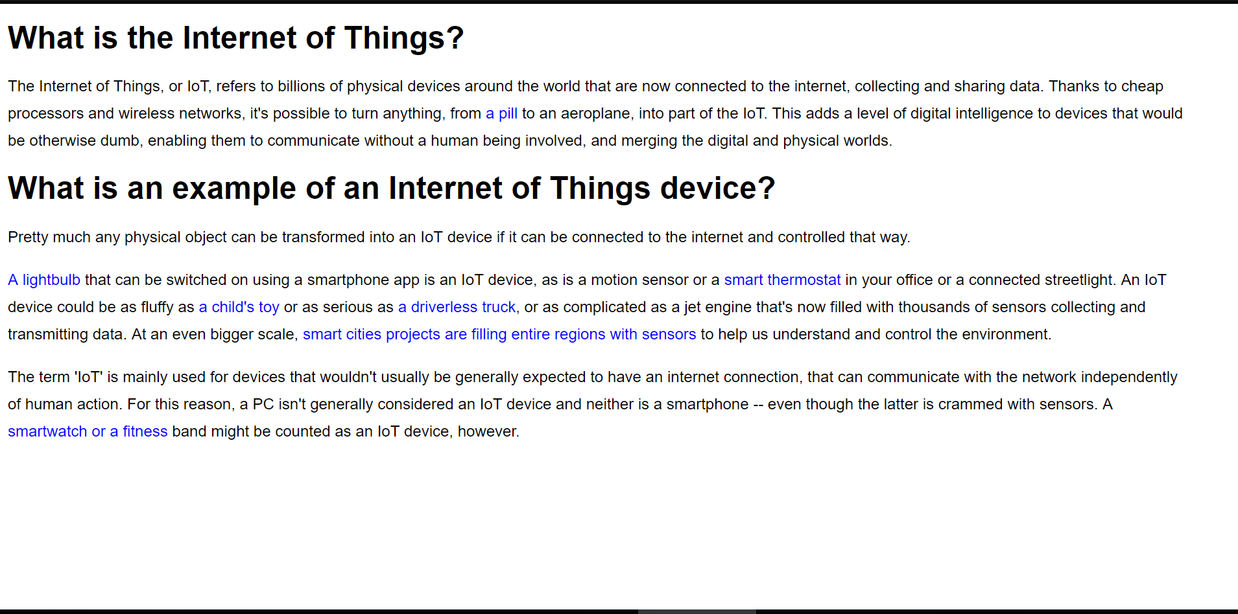

**11**

**CODE:**

<!DOCTYPE HTML>

<html>

<body>

<div style="border:5px dotted blue;padding:100px;">

<div style="border:5px dashed red;padding:100px;">

<div style="border:5px solid green;padding:50px;text-align:center;font-size:15px;">

Every webpage you look at is written in a language called HTML.

You can think of HTML as the skeleton that gives every webpage structure.

In this course, we'll use HTML to add paragraphs, headings, images and links to a webpage.

In the editor to the right, there's a tab called test.html.

This is the file we'll type our HTML into.

See the code with the &lt&gts?

That's HTML!

Like any language, it has its own special syntax (rules for communicating).

</div>

</div>

</div>

</body>

</html>

**OUTPUT:**

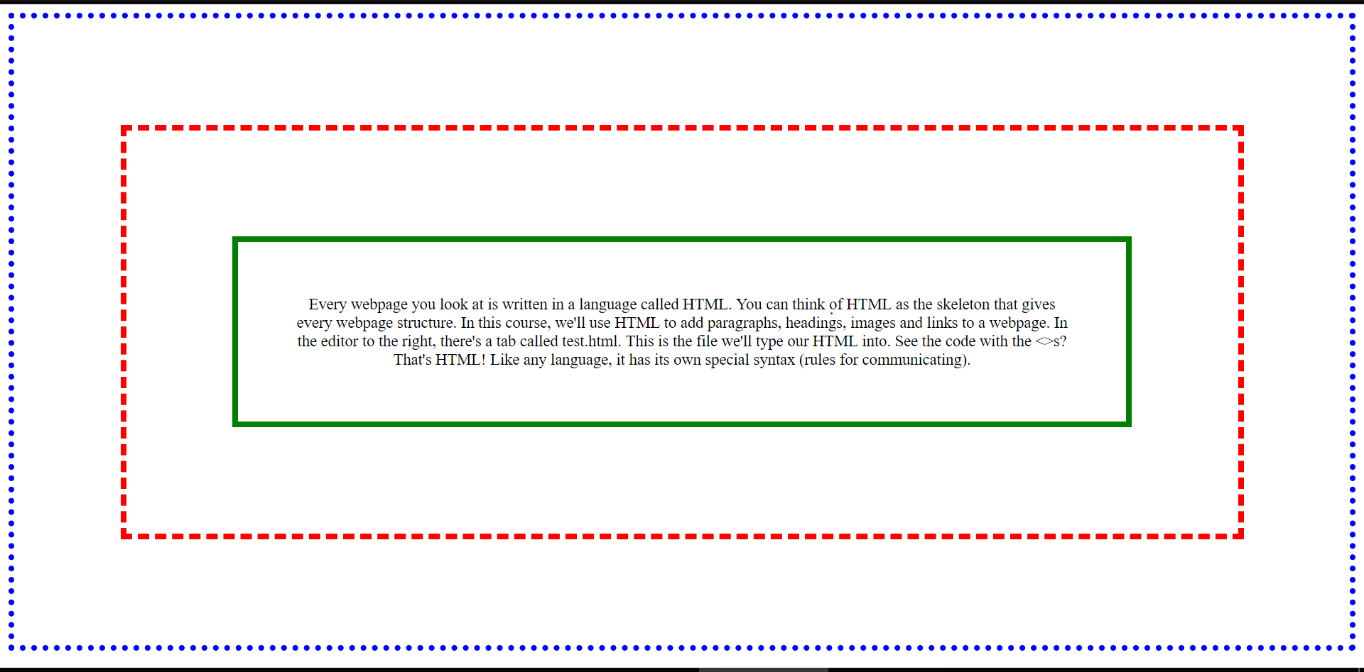

**12**

**CODE:**

<!DOCTYPE HTML>

<html>

<head>

<style>

body {

font-family: "Raleway",sans-serif;

font-size: 16px;

line-height: 28px;

width: 95%;

}

</style>

<body>

<h1/>What is the Internet of Things?</h1>

<p style="background-color:orange;">

The Internet of Things, or IoT, refers to billions of physical devices around the world that are now connected to the internet,

collecting and sharing data. Thanks to cheap processors and wireless networks, it's possible to turn anything,

from <span style="color:blue;">a pill</span> to an aeroplane, into part of the IoT. This adds a level of

digital intelligence to devices

that would be otherwise dumb, enabling them to communicate without a human being involved, and merging the digital and physical worlds.</p>

<h1>What is an example of an Internet of Things device?</h1>

<p style="border:5px solid green;padding:2px;">Pretty much any physical object can be transformed into an IoT device if it can be connected to the internet and controlled that way.</p>

<p style="background-color:pink;"><span style="color:blue;">A lightbulb</span> that can be switched on using a smartphone app is an IoT device, as is a motion sensor or a

<span style="color:blue;">smart thermostat </span>in your office or a connected streetlight. An IoT device could be as fluffy as <span style="color:blue;">a child's

toy </span>or as serious as <span style="color:blue;">a driverless truck</span>, or as complicated as a jet engine that's now filled with thousands of sensors collecting and

transmitting data. At an even bigger scale, <span style="color:blue;">smart cities projects are filling entire regions with sensors</span> to help us understand and

control the environment.

</p>

<p style="background-color:lightblue;">The term 'IoT' is mainly used for devices that wouldn't usually be generally expected to have an internet connection, that can communicate

with the network independently of human action. For this reason, a PC isn't generally considered an IoT device and neither is a

smartphone -- even though the latter is crammed with sensors. A <span style="color:blue;">smartwatch or a fitness</span> band might be counted as an IoT device, however.

</p>

</body>

</html>

**OUTPUT:**

